OPTIONAL HEALTH BENEFITS

<https://www.benefeds.com/programs>

These Plans require a separate enrollment and additional costs – Read Plans carefully

New hires have 60 days from start date to enroll.

Department of the Air Force civilian employees can contact the Plans directly with questions.

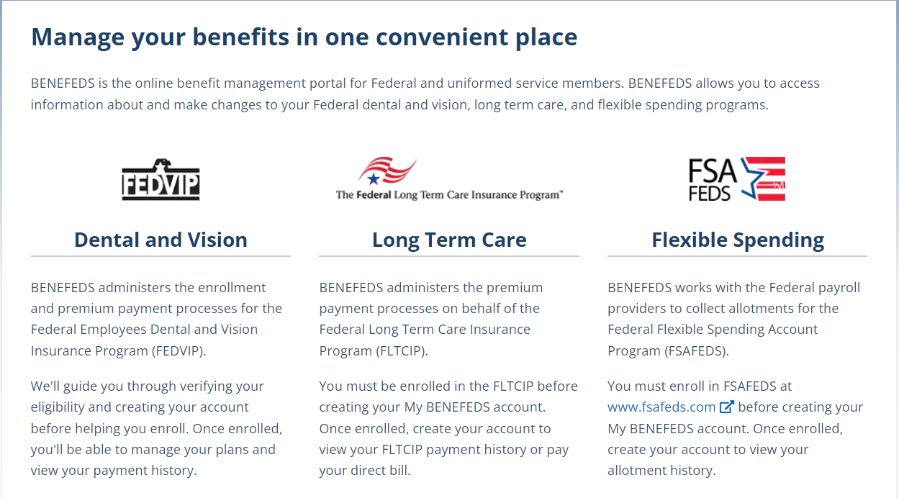

Federal Vision and Dental (FEDVIP) 1-877-888-FEDS

Long Term Care (LTC) – Enrollment link: <https://www.ltcfeds.com/>

Enrollment Call Center 1-800-LTC-FEDS 8 am – 6 pm Eastern Time

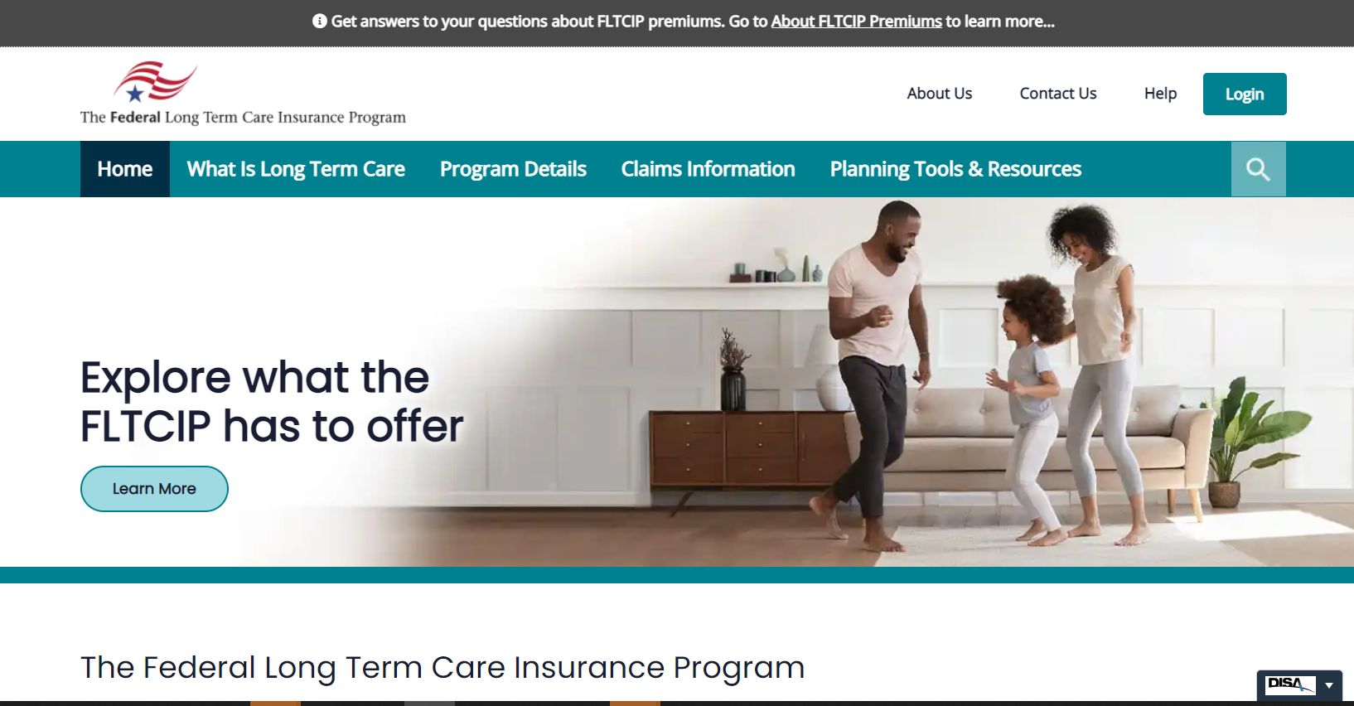

Flexible Spending Account (FSA) – Enrollment link: <https://www.fsafeds.com/>

877-FSAFEDS Mon-Fri 9 am – 9 am Eastern Time

